Angular Material and Header Setup
Objective:
- Adding Angular Material
- Setting up a basic visual foundation
- Creating a reusable header component
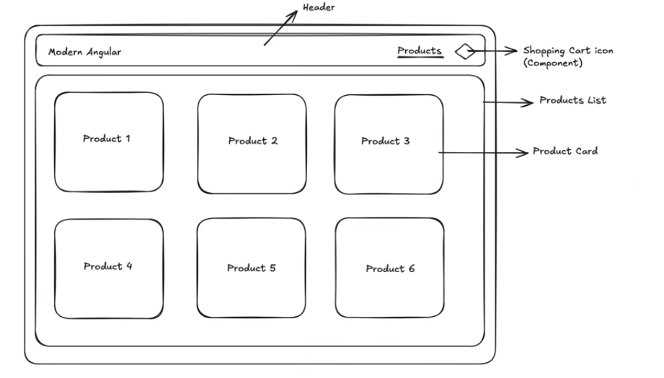
- Start command window with admin right
- Run the following commands from the command windows
  - cd\
  - md Day3
  - cd Day3
  - ng new store (accept all default by just pressing <Enter>)
  - cd store
  - code . (now, you will open the new store project from VS Code.
- Close the command window
- Switch to VS Code
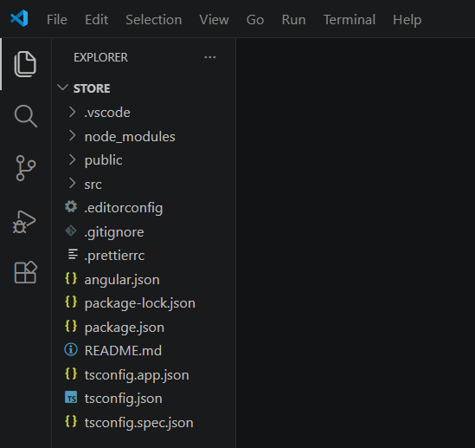
- Meanwhile, open web browser and navigate to the official Angular Material site: https://material.angular.dev/
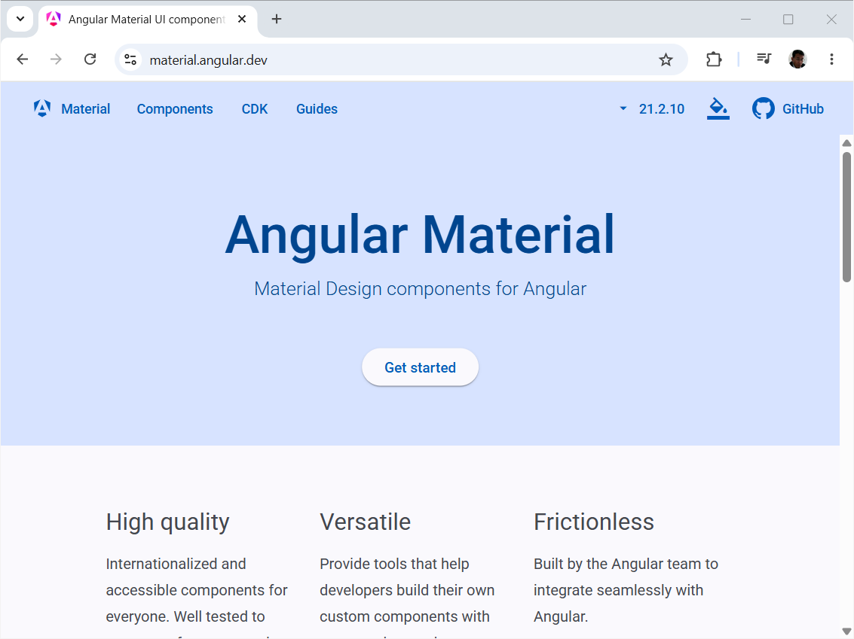
- Click on the Guides and “Getting Started”
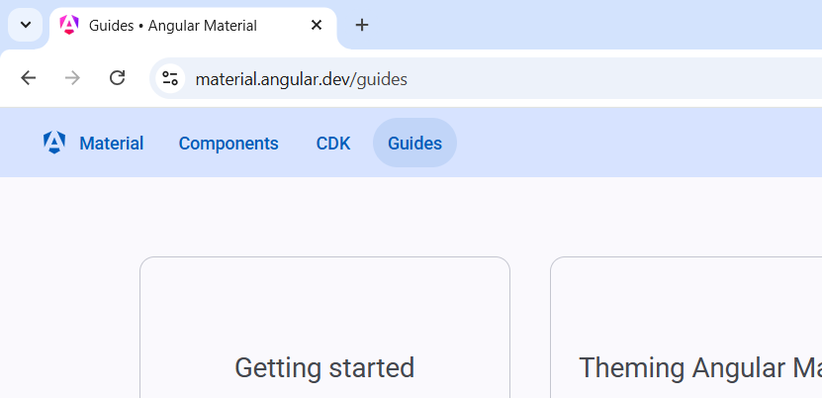
- Copy this command : ng add @angular/material
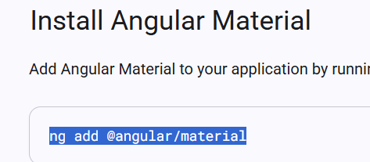
- In the VS Code terminal, run this command
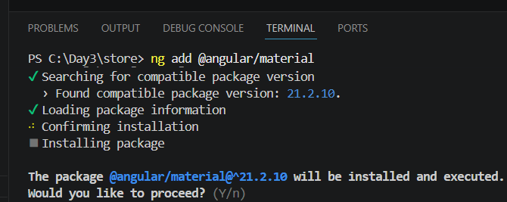
Just press <Enter> to accept all the options
- Back to the Browser, navigate to the component page.
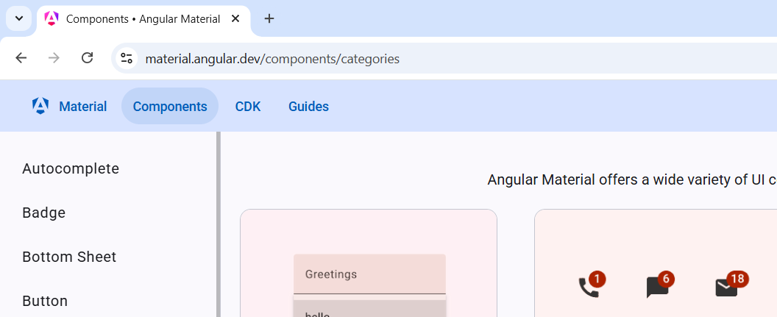
- In VS Code, lets create a header component from the Terminal: ng g c header
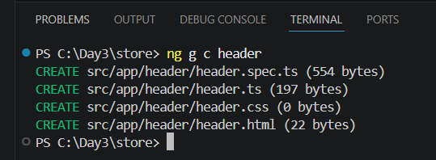
- Select the app.ts and add the following
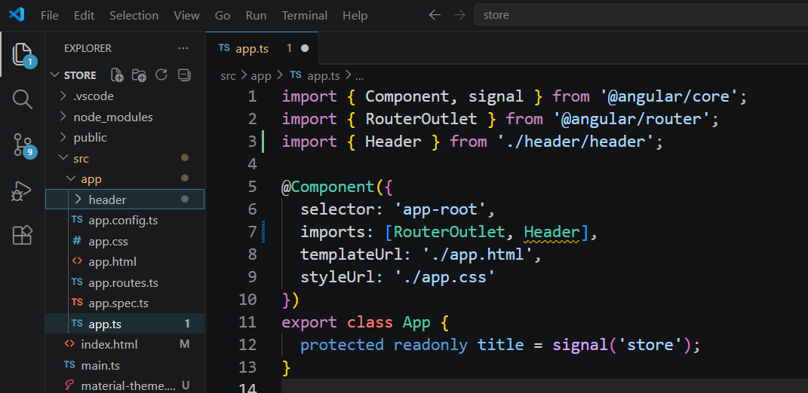
- Select the app.html and change the content
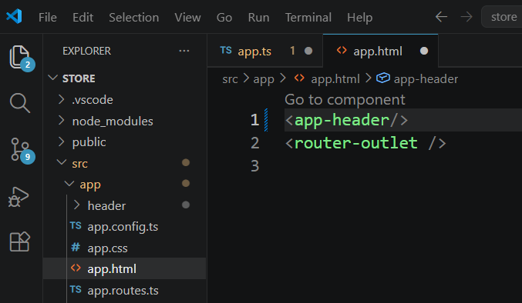
- Save all (Ctrl+K+S)
- Rename the Terminal to Server, and run ng serve --open
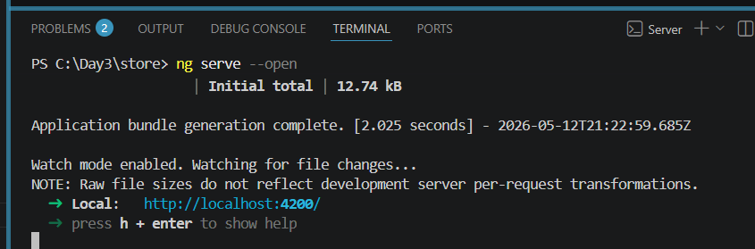
Now you should get the browser open
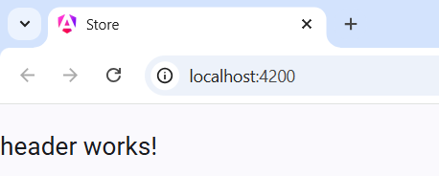
- Add another new Terminal window for other command later
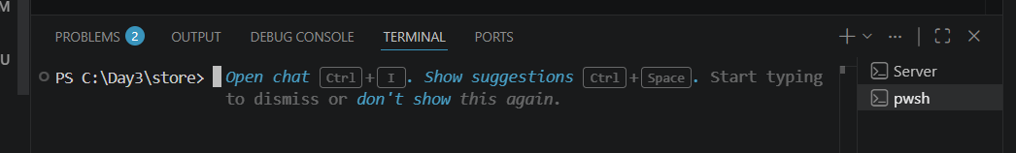

- Back to the Angular Material page, under the component, select toolbar, API, and copy the import statement.
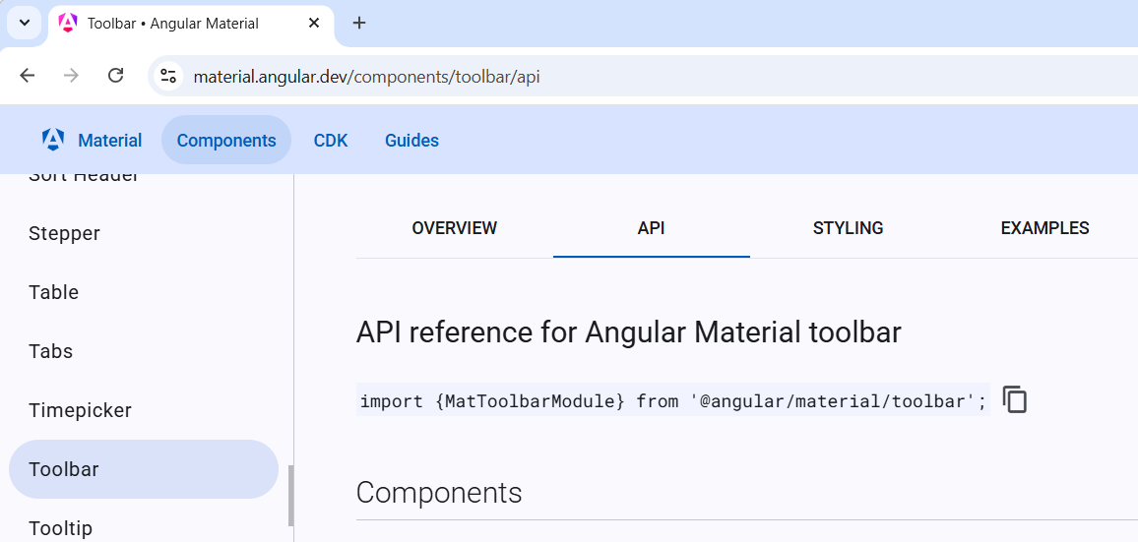
- Paste it to header.ts. Don’t forget to add the MatToolbar to imports as well.
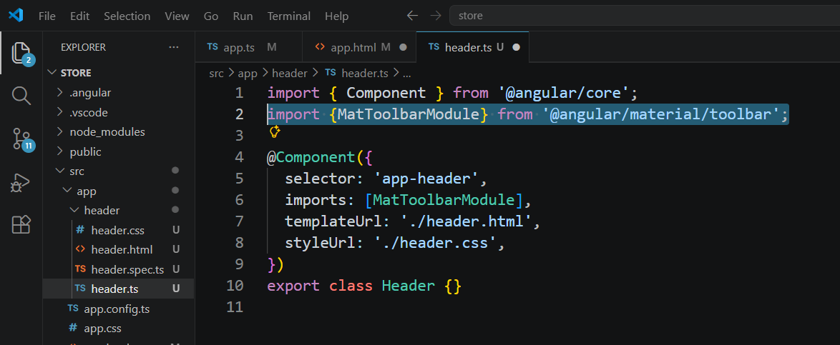
- Change the header.html
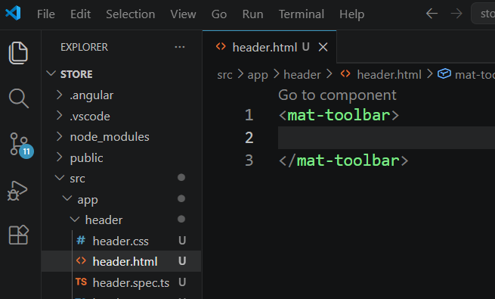

- In component page, select the import statement from Button.
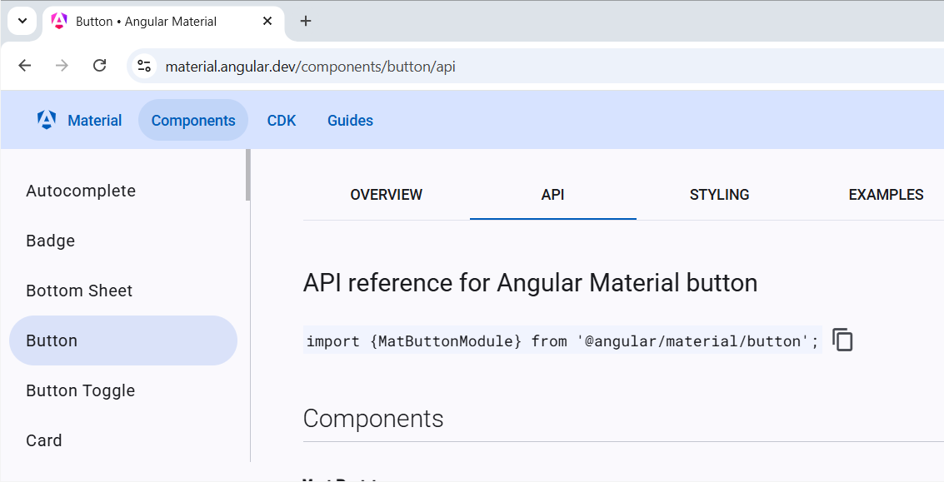
Paste to add it to header.ts
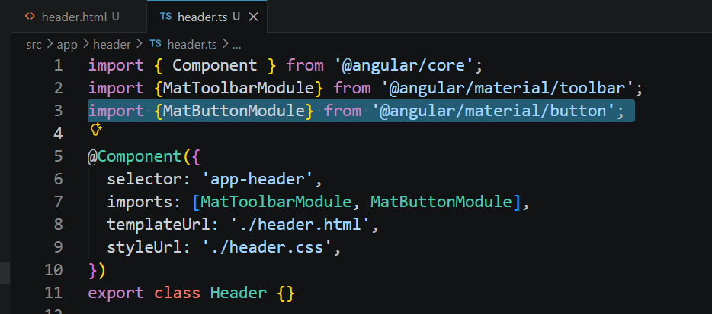
- Copy the icon
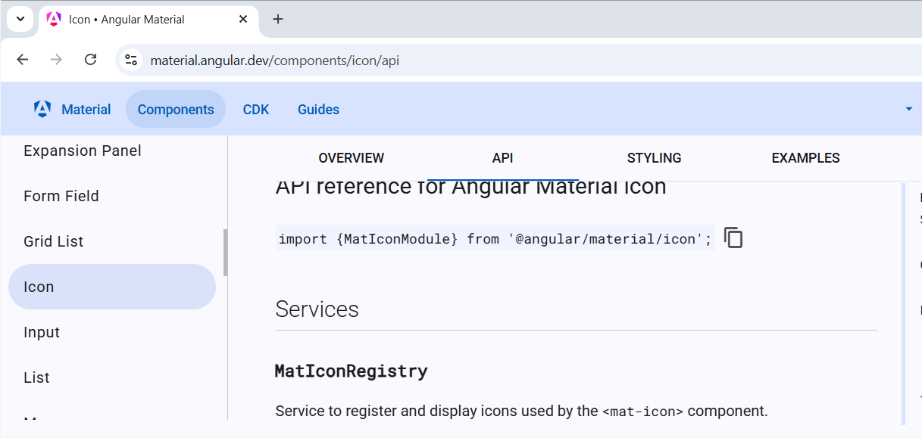

- Add to header.ts
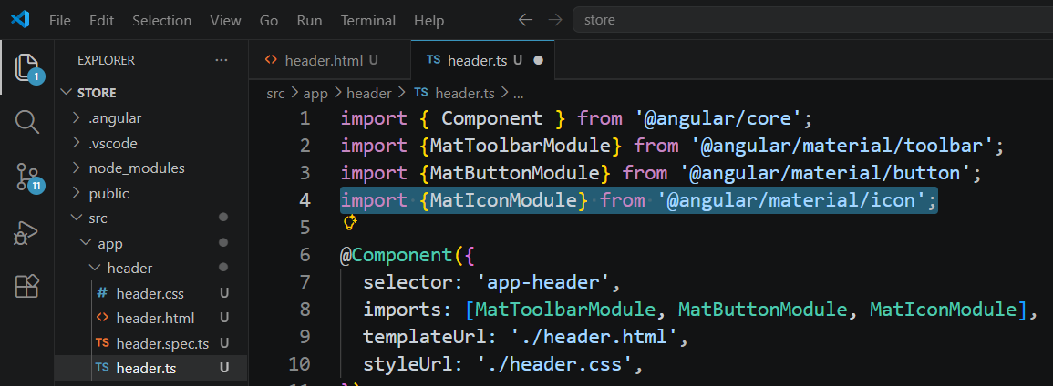
- Copy the HTML tag of icon
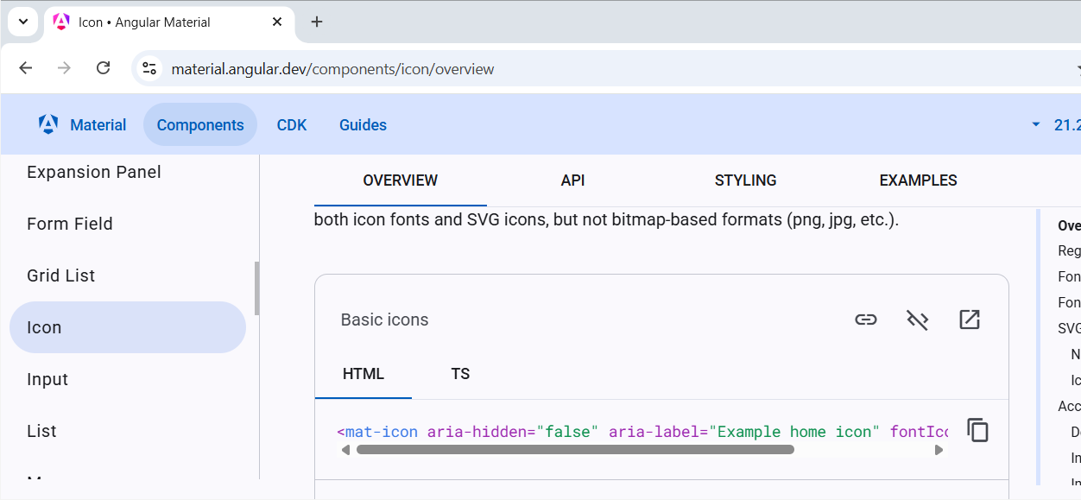
- Patse it to header.html. Place the tag inside the <button> tag
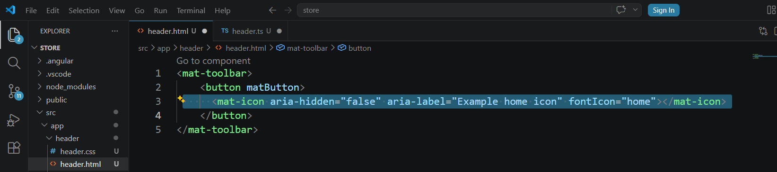
- Save all. Now the webpage will look like this
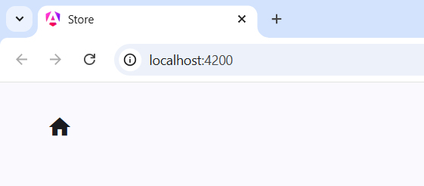

- Try change the icon to “store” in header.html. Save it
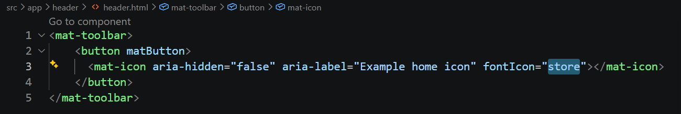
The webpage changed to
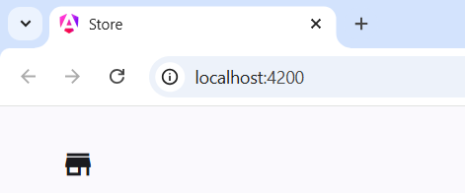
- Change the header.html with following code:
<mat-toolbar>
<button matButton>
<mat-icon aria-hidden="false" aria-label="Example home icon" fontIcon="store"></mat-icon>
</button>
<span>Modern Angular</span>
<span class="spacer"></span>
<button matButton>Products</button>
<button matButton>
<mat-icon aria-hidden="false" aria-label="Cart" fontIcon="shopping_cart"></mat-icon>
</button>
</mat-toolbar>

Save it, the webpage changed
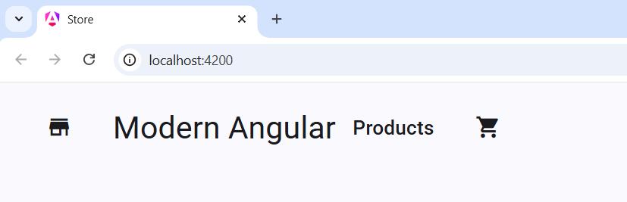
- Prepare the CSS for header. In header.css
.spacer{
flex: 1 1 auto;
}
.main-header{
padding: 0 6px;
position: relative;
box-shadow: 0 1px 8px rgba(0,0,0,.3);
z-index: 9;
}
.branding{
display: flex;
overflow: hidden;
text-overflow: ellipsis;
white-space: nowrap;
margin: auto 0;
line-height: 50px;
padding: 0 64px 0 8px;
}
- Add class to tags in header.html
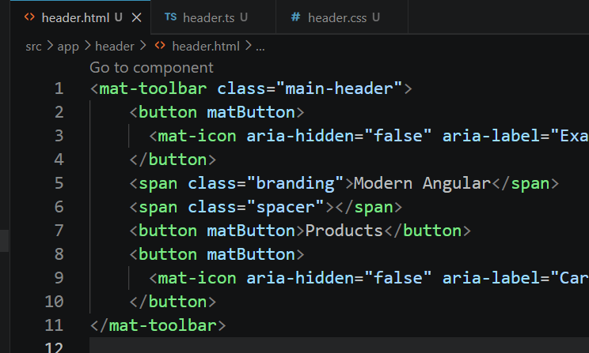
- Save all. The wed page changed
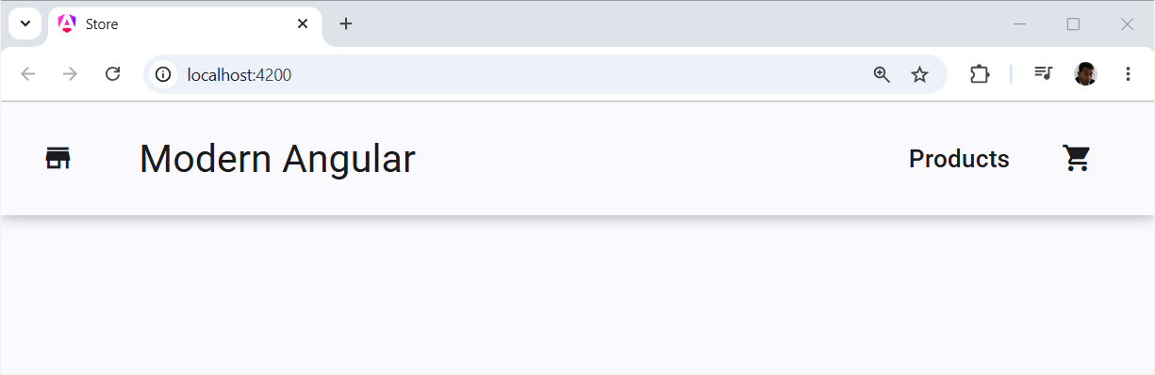
- Try resize the browser window.

